Large Print and Screen Reader Version of the UNTITLED Exhibition Guide

Cover of Exhibition Guide
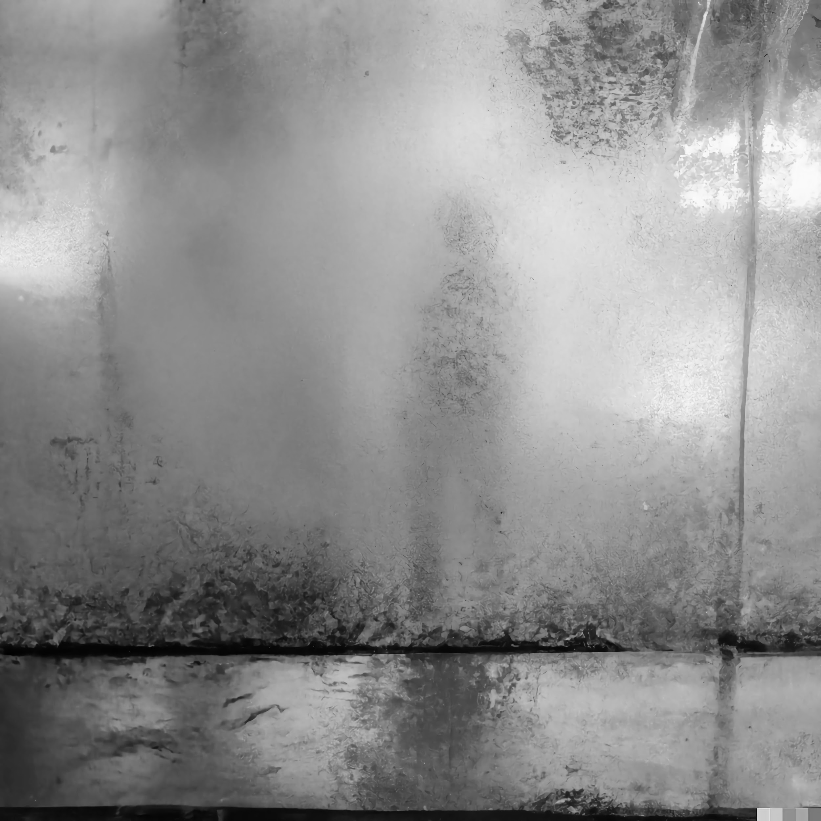

Image description:
A black and white image of an opaque wall, a silhouette of a figure is visible. There is a puddle in front of the wall, and there may be trees in the background. The atmosphere suggests a foggy or rainy setting.

The text on the cover reads:
UNTITLED
02.01.24
Exhibition Guide

The artists featured in the exhibition guide include:
Flo Jansen
Ell Hamond
Emma Astra
Charley Skinner

Inner pages - Featured Artworks

Artwork 1

Image description:
A black and white image of a statue of a man in a suit and tie holding a cane. It is located indoors, likely in a museum.

Title:
‘It’s Rude to Stare’
Artist:
Flo Jansen
Link to artists’ Instagram account, @flosfunkyfellas

Artwork description written by the artist:
Before entering the exhibition, a crucial decision must be made. Will you wear a bald cap or a wig? Or perhaps stay as you are?

Upon crossing the boundary, your cosmetic wishes will be granted. A lanky gentleman sits poised in the centre of the room. He’s an intimidating figure; comparable in height to a double-decker bus yet roughly the width of a smart car. He lurches forward periodically, inexplicably drawn to those with hairless heads like a magpie to shiny objects. His equally enormous top hat and cape evoke a bygone era. As he sways, metal joints and circuits that strain beneath his garments suggest otherwise. He contorts again, changing direction to gaze at only the most follically-challenged visitors, his crooked nose tracing the glass cylinder around him.

Those bald enough to stare back heed this warning: the eyes are the window to the soul.

Artwork 2

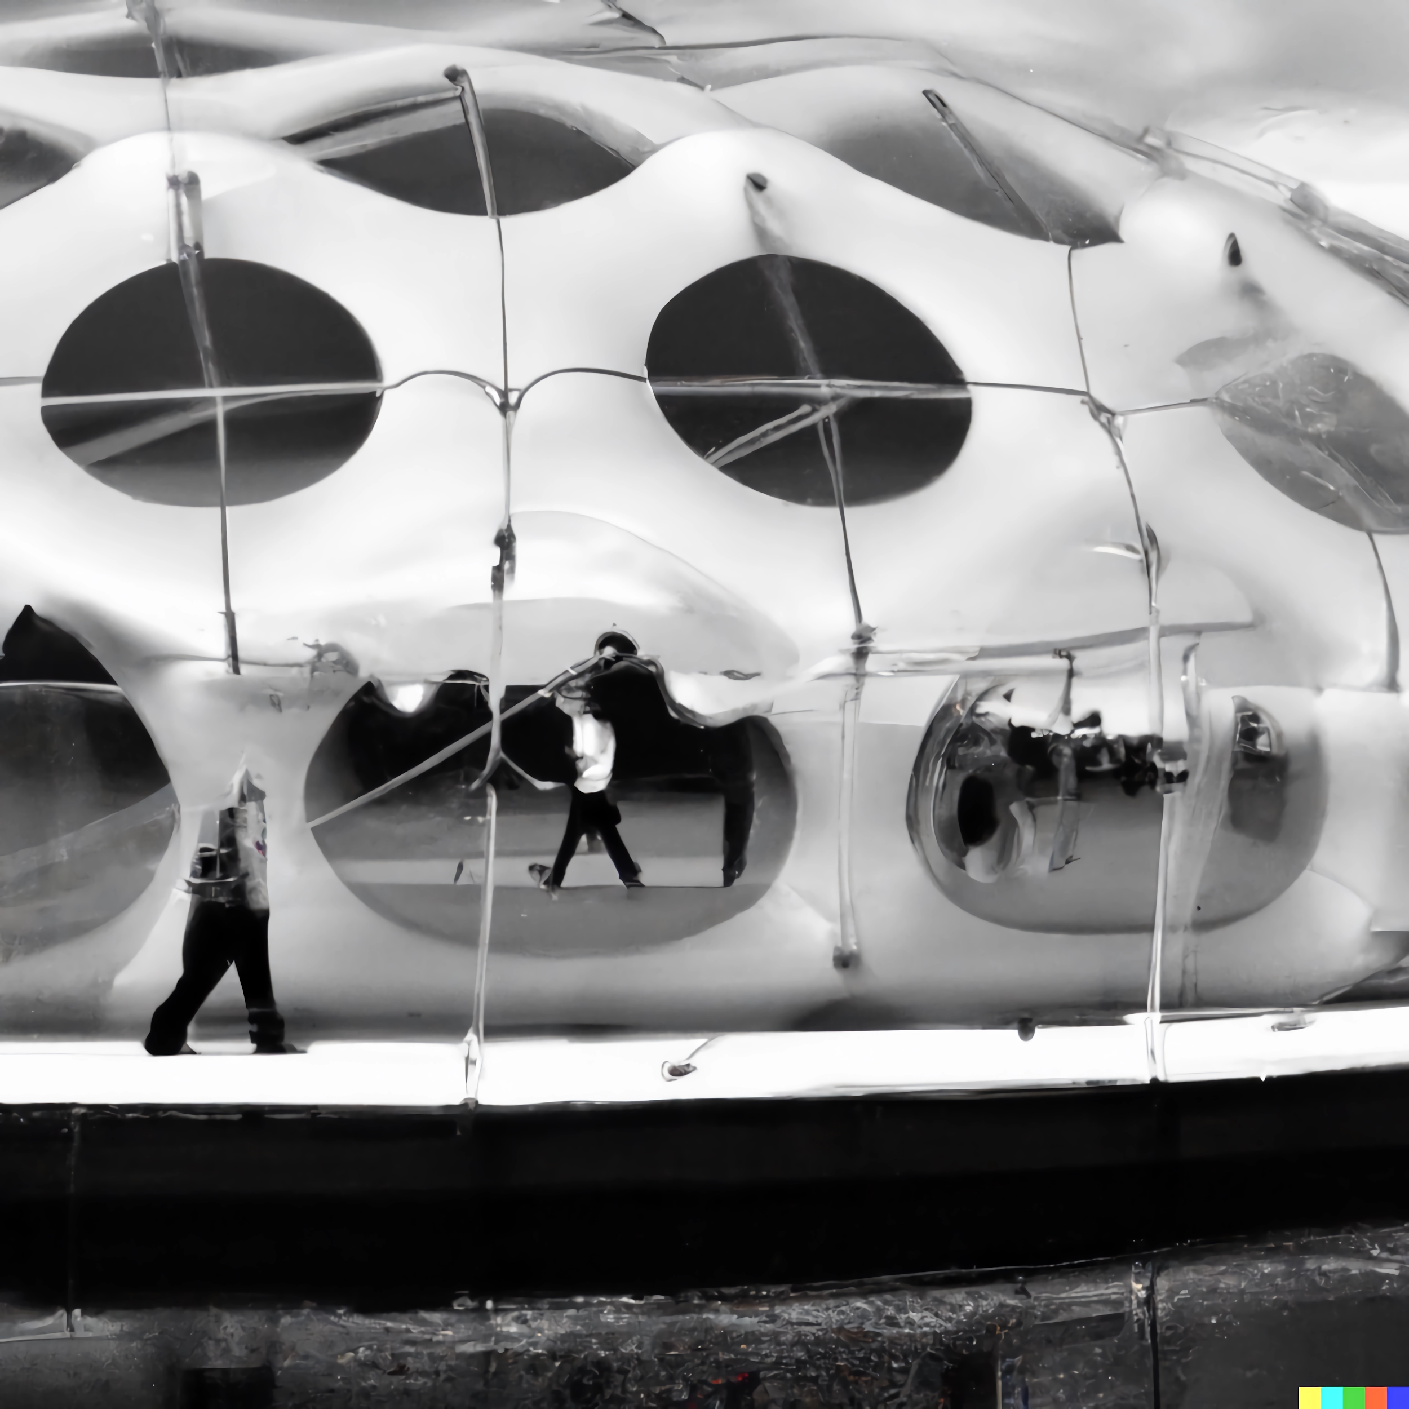

Image description:
A black and white image of people walking out of an inflatable structure resembling a space shuttle. It shows outdoor surroundings with clouds in the background.

Title:
‘A Fluid Utopia’

Artist:
Ell Hammond

Link to artists’ Instagram account, @_el_13_

Artwork description written by the artist:
Imagine a world where there is no defined gender restriction. This artwork represents that world.

You are permitted one-way travel on the Wonderfully Colourful ferry, guarded by the Goddess of Fluidity, to an inflatable structure moored nearby on the river Derwent (see notice board, and follow signage).

Upon reaching the inflatable, you are welcome to explore several rooms. Each has crystal-clear walls filled with water and floating artworks: performances and video by gender-fluid artists. You’ll feel as if you have travelled to another world, a gender-fluid world, one that celebrates and encourages a deviation from gendered norms. Surrounded by fluidity from the walls to the floor, you will experience what life should be like.

Once you stumble from the structure, you must return to dry land on a drab, cricked boat, guarded by the God of the Norm.

Artwork 3
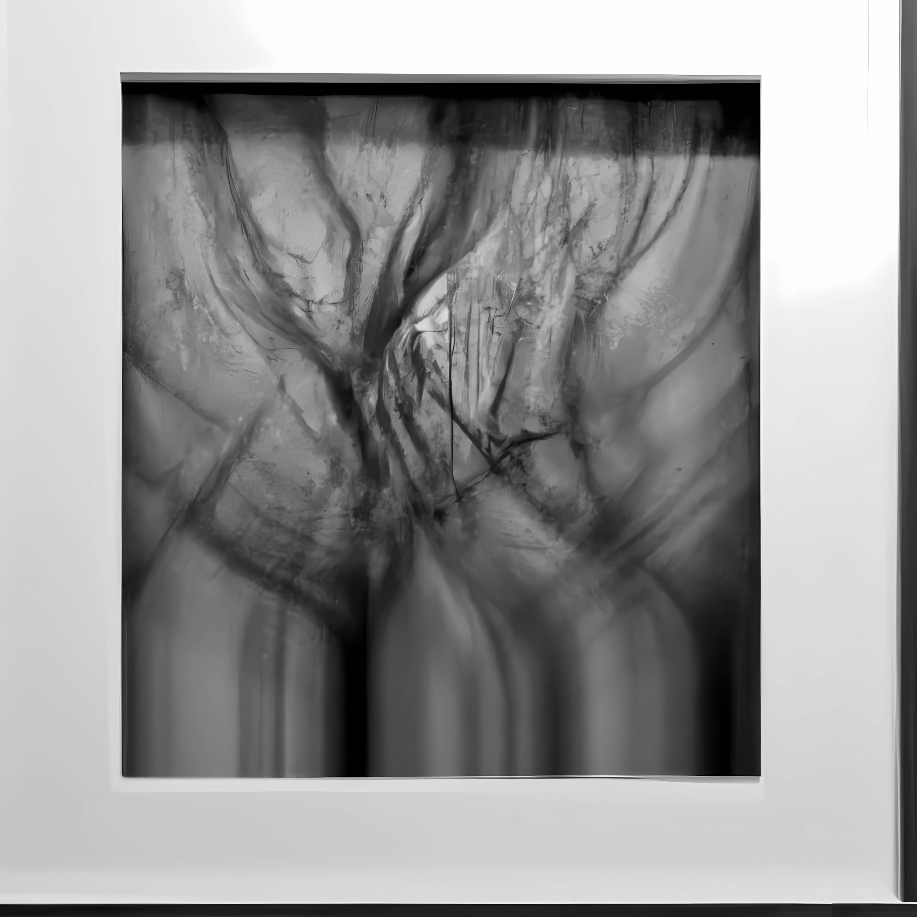

Image description:
A black and white image of a blurred tree framed by a picture frame mount. The image resembles an x-ray film.

Title:
‘But You Don’t Look Ill’
Artist:
Charley Skinner
Link to artists’ website www.charleyskinner.com

The artwork displayed is an emotional exploration, within a larger series, capturing the visual essence of living with a chronic illness. The photographs delve into the elusive symptom of brain fog: fuzzy thinking, scattered focus, feeling like your mind is stuck in a cloud.

The photographs show the whimsical dance of tree branches on a windy day. A mirror image of the disorienting nature of cognitive struggles associated with a chronic condition. The large, black and white print invites you into a world of abstraction, skilfully captured through a deliberate slow shutter speed, and lack of focus.

The artwork conveys the tangible weight and exhaustion that accompanies brain fog. Each print is encased within a time- worn wooden frame. The material choice serves as a metaphor for the chronic constraints and challenges

Artwork 4
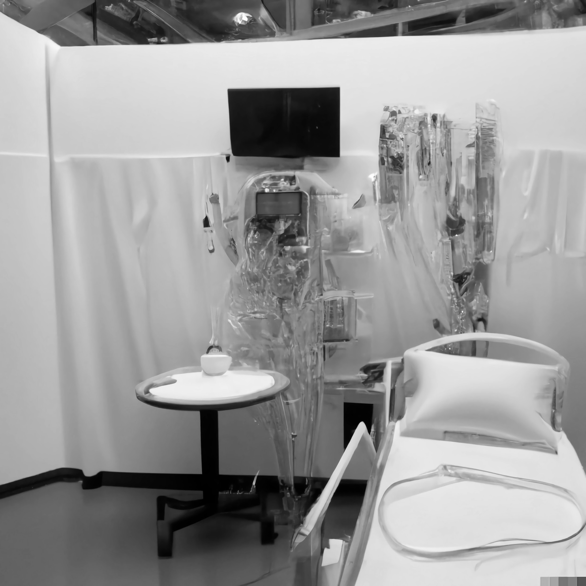

Image description:
The black and white image depicts a hospital room with a table, chairs, and medical equipment. The room and the setting suggest a medical environment.

Title:
Trial by TikTok

Artist:
Emma Astra
Link to artists’ linktree, linktr.ee/disabledphdstudent

Artwork description written by the artist:
Please be aware of the trip hazards as you move around the hospital room installation. Trailing cables and tubes connect to IV drips, monitors, and electrical equipment, all around the hospital bed.

Laptops and phones are spread across the installation. If you remove the Meta-Toilet from under the desk, please return it.

A wall-mounted TV shows extracts from a vlog. If you are unable to watch the full video (54m), a condensed description of the events discussed follows.
- The UK government funds a disabled initiatives company to host a major art exhibition, providing future work opportunities for disabled people.
- Six disabled creatives feature in a local newspaper article celebrating their involvement in the exhibition.
- All creatives with work in the exhibition receive letters stating that their benefits are being sanctioned, because the almighty ‘computer said so’.
- Creatives are unable to get to High Court to make an appeal due to various issues with public transport, care needs, and toilet access.
- The artists are deported to Rwanda, under new laws extending beyond refugees, to anyone relying on the state.

Back Cover

The back cover features information about the Untitled exhibition, a floor plan and logos of the partners involved in delivering the project. The page is printed in black and white.

The body of text reads:

About Untitled Exhibition

If you could make anything, what would it be? Seriously, it could be anything. Don’t worry about the budget, time, space, or resources involved. This is the prompt we’ve asked creatives to respond to for UNTITLED.

The four creatives featured in the exhibition were selected from a Midlands-wide open call for disabled, early-career creatives, working in the visual arts. They were asked to write a description of a fictional artwork that they would like to make and share in a gallery space.

The project aimed to address barriers to practise and highlight the inaccessibility of many open calls for disabled creatives. All work was delivered flexibly and remotely.

Floor Plan

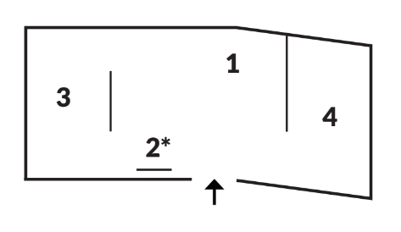

Image description:
A small digital line drawing of QUAD’s main gallery containing the numbers 1, 2, 3, 4 is printed underneath. There is a small note to the side that reads: See notice board for A Fluid Utopia directions and sailing times.

Partner logos are printed in a line near the bottom of the back cover for the organisations involved in the Untitled exhibition: QUAD, No Jobs in the Arts, Dizzy Ink, and Arts Council England.

The exhibition was delivered by Derby QUAD and No Jobs in the Arts, and generously supported by Arts Council England. The publication was printed by Dizzy Ink.

A screen-reader friendly version of this document can be found online, please see www.nojobsinthearts.co.uk/projects/untitled/

Transcript by No Jobs in the Arts. Document follows MS03 UKAAF, minimum standards for clear and large print. Permission, to produce the large print version of the document has been confirmed.

