**Screen Reader Transcript of the Digital Zine:  
No Jobs in the Arts Issue #9**

**May 2025**

**[Start of No Jobs in the Arts Issue 9]  
  
Page 1 (front cover) – Image 1**

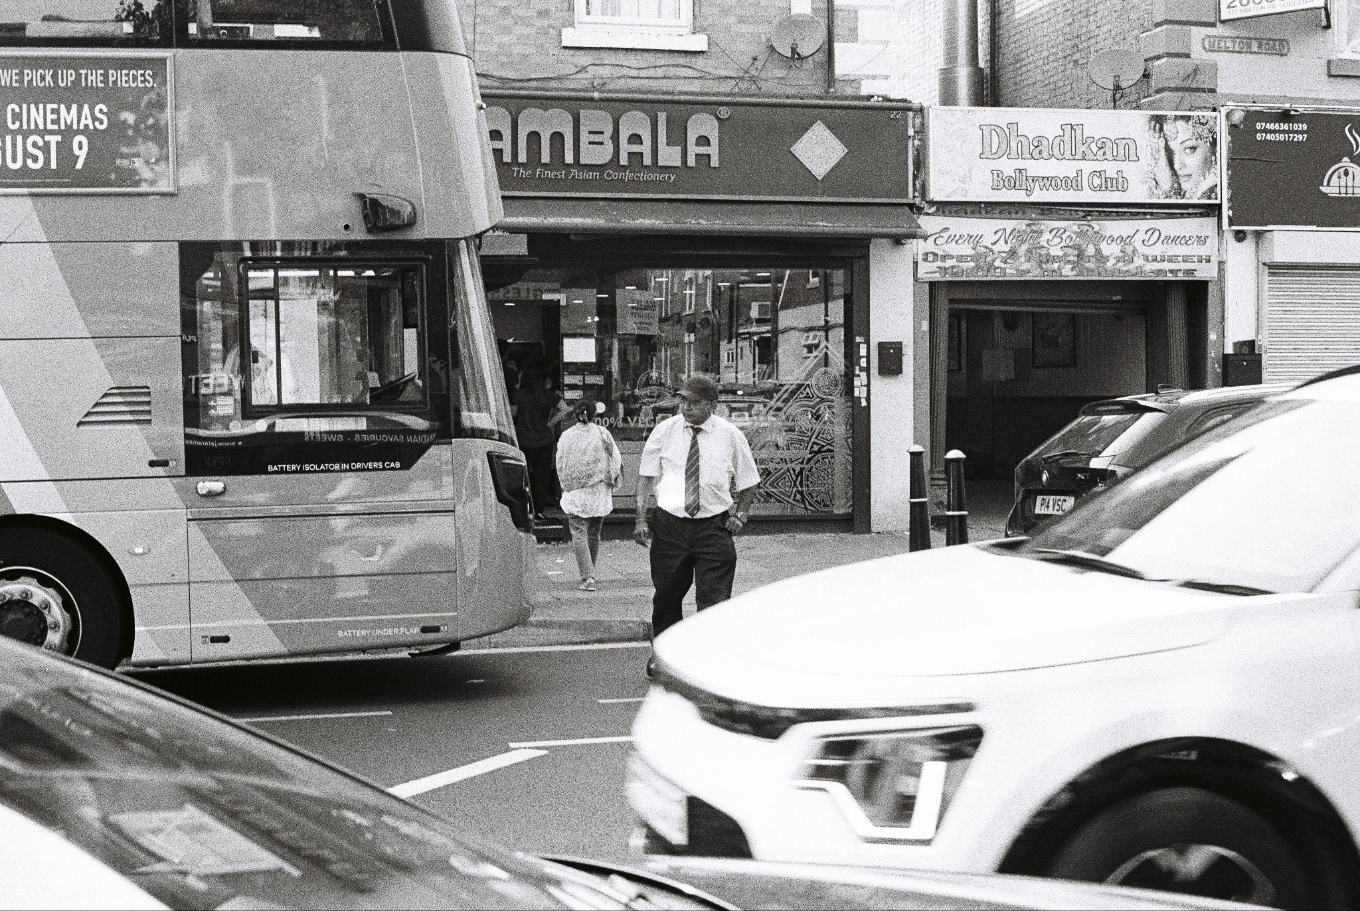

**Image Description:**

A black and white photograph of a street scene. In the foreground, a bus and a car are visible. In the background, there’s a storefront. Two people are in the frame—one walking towards the store, and another standing in the road near the bus, presumably the driver, facing the camera.

**Image details:**  
Artist: Raj Lalli  
Title: Bus Driver  
Date: 2024  
Instagram: @raj_lalli ([click here to visit the artist’s Instagram](https://www.instagram.com/raj_lalli))

**On the first page of the publication, No Jobs in the Arts have added their logo. They have also added a piece of text, ‘contains personal narratives’, to complete the cover of Issue #9.**

**Page 2** - **Image 2**

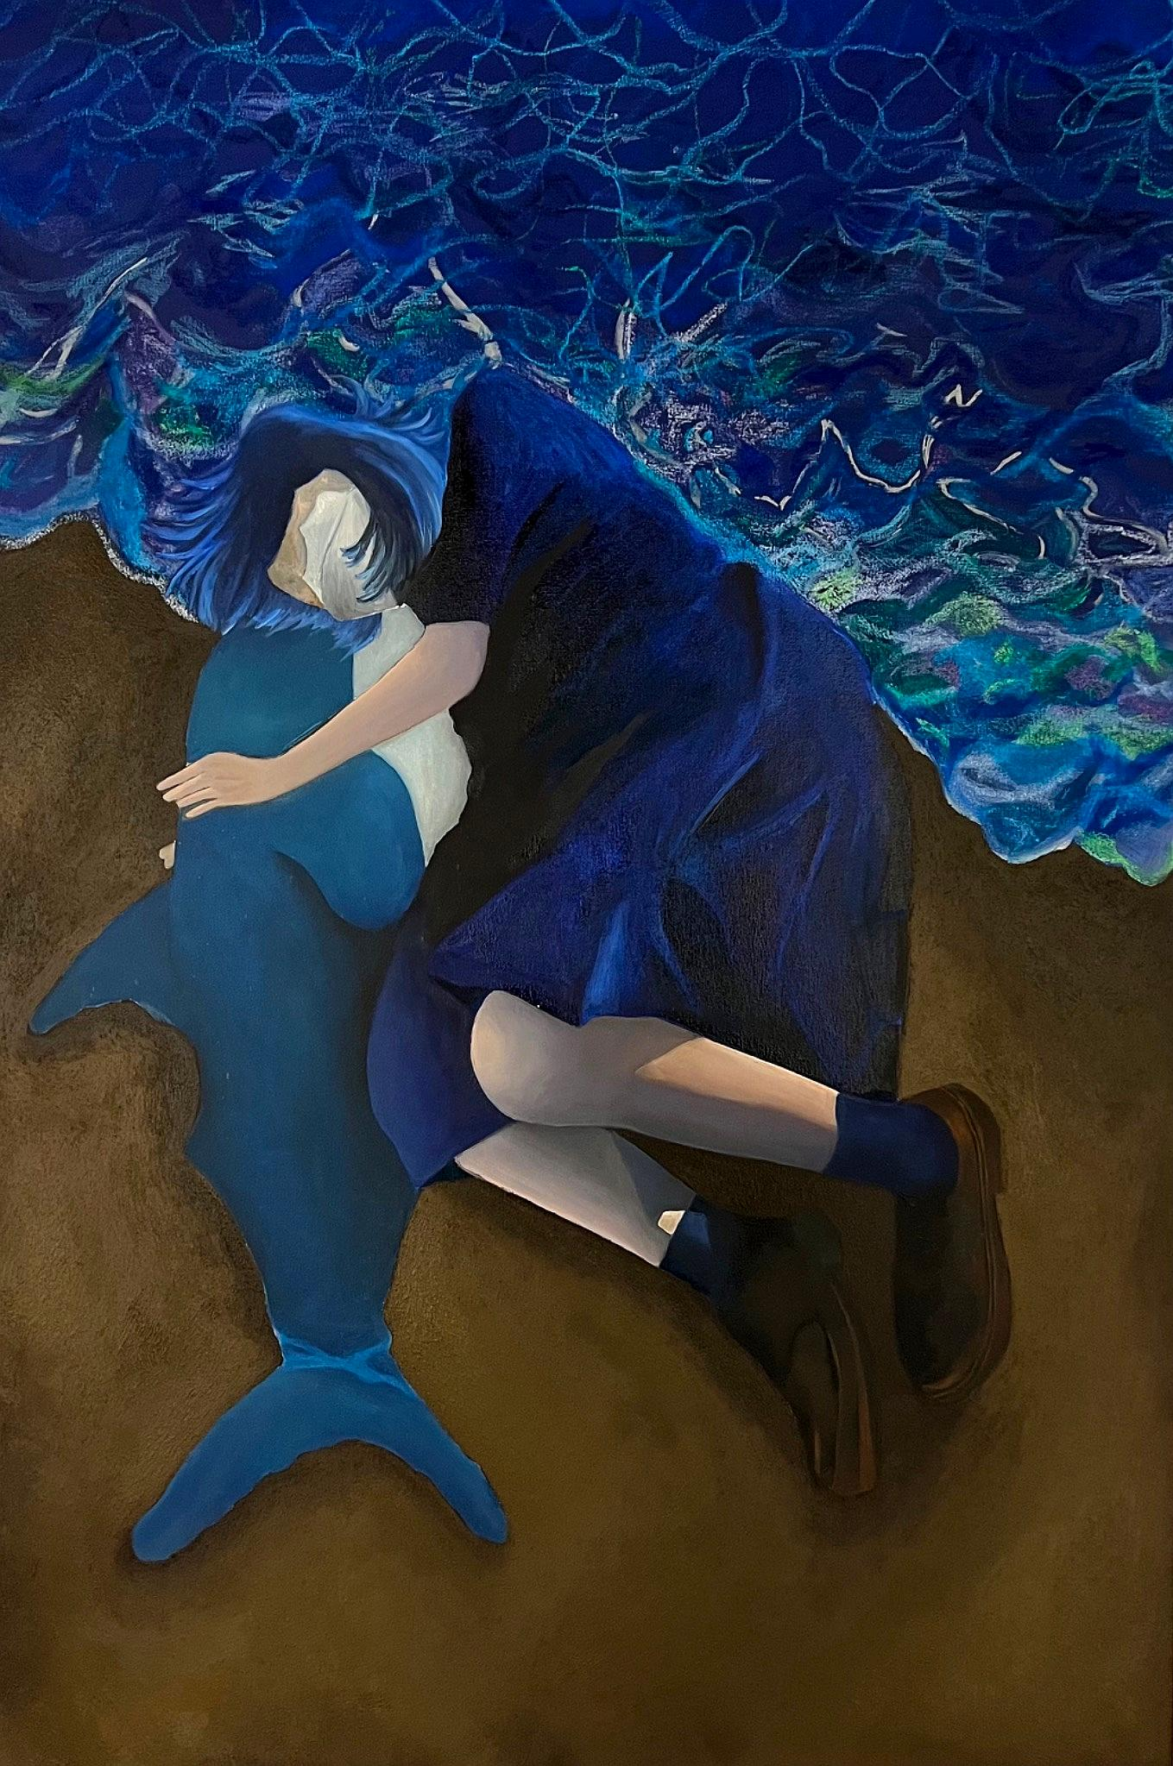

**Image Description:**Painting of a person lying on sand, embracing a blue shark. The person is wearing a dark blue dress and black shoes. Half of the background features a dark blue, wavy pattern that resembles the ocean.

**Image details:**

Artist: Litco  
Title: Untitled  
Date: 2023  
Descriptive tags: Painting, Connections, and Positionality  
Instagram: @litco.litco [(click here to visit the artist’s Instagram)](https://www.instagram.com/litco.litco)

**Page 3 - An Interview with Litco**

**Question 1:** What is the meaning of the embrace in this artwork?

**Answer to Question 1:** The act of embracing symbolises both comfort and contradiction. The figure clings to the shark, an entity that embodies both danger and solace, reflecting the emotional complexities of migration and human connection. It represents the need to hold onto something familiar - even when it carries risk - mirroring the way immigrants often navigate uncertainty, longing, and adaptation. The embrace becomes a metaphor for resilience, vulnerability, and the delicate balance between fear and comfort in unfamiliar environments.

**Question 2:** What are the main themes you explore in your work?

**Answer to Question 2:** The main themes I explore in my work include human connection, absence, and emotional processing through participatory and interactive art. My creative projects such as Sze You Tomorrow? examine loss, distance, and fragility, often reflecting on personal relationships shaped by migration and disconnection. I incorporate memory, liminal spaces, and reimagine Hong Kong cultural rituals to question presence and absence. Through audience participation, I encourage reflection on longing and the fragility of human bonds.

**Question 3:** How does your practice challenge how we look at interconnectedness?

**Answer to Question 3:** My practice challenges perceptions of interconnectedness by exploring how migration, distance, and absence reshape human bonds. A recent project, Sze You Tomorrow? looked to preserve my connection with my friend Szeto: the project evolved into a search after her disappearance. Using missing person posters, fading figures, and immersive installations, I highlighted the fragility of memory and relationships across borders. Ultimately, my artworks examine the instability of connection in transient spaces, urging reflection on how migration alters emotional ties and how we navigate loss across time and distance.

**Page 4** - **Image 3**

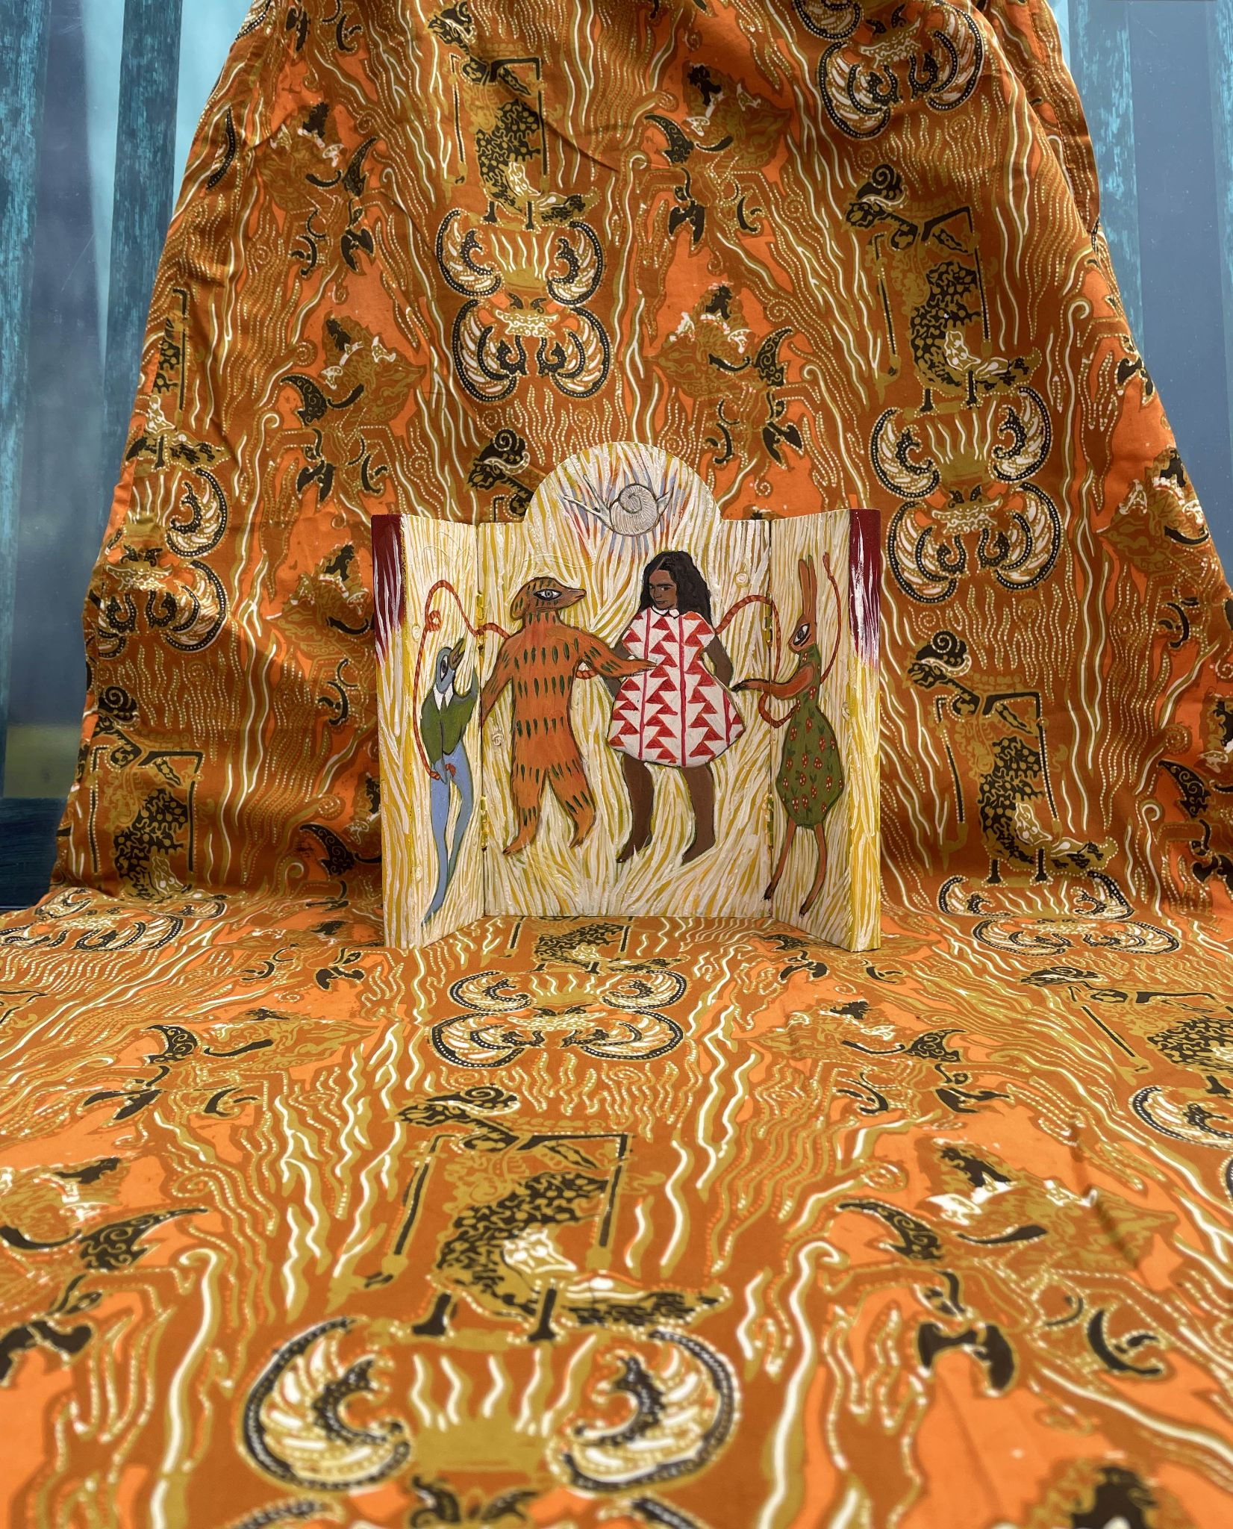

**Image Description:**The image showcases a tapestry filled with intricate patterns and vibrant colors, alongside swirling motifs in rich hues of orange, yellow, and brown. A painted wooden panel is at the centre of the image. Four figures feature, three are representations of animals, a rabbit, dog and a bird. A child occupies the middle of the image. All are dressed in multicoloured, patterned garments and stand interconnected with a red ribbon. A monochromatic snail edges across the top of the panel.

**Image details:**

Artist: Sarogini Reddiar  
Title: Spirit House  
Date: 2025  
Descriptive tags: Painting, Generational Trauma, and Childlore  
Instagram: @saroginireddiar [(click here to visit the artist’s Instagram)](https://www.instagram.com/saroginireddiar)

**Page 5 - An Interview with Sarogini Reddiar**

**Question 1:** What does this piece communicate?

**Answer to Question 1:** This piece explores the idea of carrying fragments of the self, the psyche, including the inner child, with a reverence for the parts of memory held by each. Inspired by religious icons, I created it reflecting on my journey from childhood trauma, dissociation from parts of memory, towards healing. My parents returned to their home country when I was a young adult—it highlighted my own fractured sense of belonging that I wanted to heal.

**Question 2:** How do you use folklore in your work?

**Answer to Question 2:** I enjoy playing with archetypes, centring these in my work as they exist innately from childhood in our psyches, and as they’re added to by cultural transmission. I draw in folkloric archetypes to represent the protective parts of the personality that help us navigate the interrelated experiences of childhood and motherhood, learning and play. The idea that in play and learning, these parts might experience the worlds of perception and imagination without any distinction.

**Question 3:** What emblems of diasporic childhood are present in your work?

**Answer to Question 3:** My childhood was shaped by a sense of belonging to many cultures but not to one, that we weren’t able to bring our history with us in material form. There’s a repeating pattern of critical parent and lost child but the main emblem is of the functional family we carry inside. While intergenerational trauma can lead to a loss of childhood memories, the reminder that there is a knowing that invites our intuition and self-trust.

**Page 6 and 7** - **Image 4**

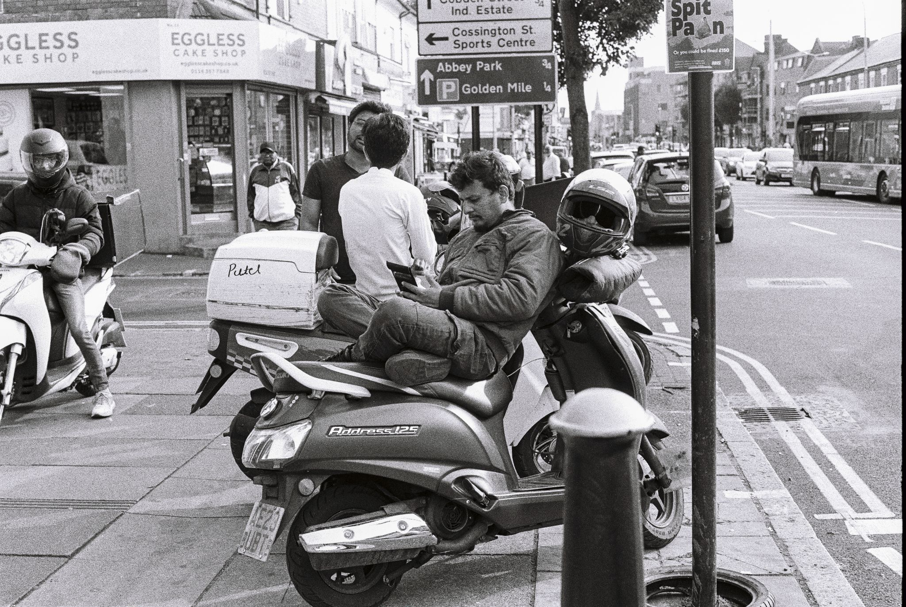

**Image Description:**The black and white photo depicts a bustling urban street scene. Two motorcycles are parked on the sidewalk, one with a helmeted rider seated on it, the other rider sits cross legged on his seat. Several pedestrians walk along the sidewalk, passing by an EGGLESS CAKE SHOP. Nearby, a sign instructs people with directions to locations in Leicester city centre. In the foreground, a traditional bollard stands erect.

**Image details:**  
Artist: Raj Lalli  
Title: Courier  
Date: 2024  
Descriptive tags: Photography, Neighbourhoods, and Identity

Instagram: @raj_lalli ([click here to visit the artist’s Instagram](https://www.instagram.com/raj_lalli))

**Page 8 (back cover) - Editorial**

‘...not just because they’re easily decodable through a western gaze.’

Issue #9 delves into practices working with immigration themes, sharing a multiplicity of experiences. The content of this zine addresses the perspectives of first, second, and third-generation migrants connected

to the Midlands.

These narratives weave through overlapping communities, spaces and timelines, capturing the in-betweens. They offer alternative re-imaginings of our shared realities, highlighting accounts that challenge the western lens.

**Credits:**

Featuring: Sarogini Reddiar, Raj Lalli, Xin Chen, and Litco  
Editors: Klara Szafrańska (guest curator for issue), Charlie Collins, and Ryan Boultbee

Project Region: Midlands

Date: 2025

Publisher: @nojobsinthearts [(click here to visit the publishers Instagram)](https://www.instagram.com/joshuanicholson______/)

**Footnotes:**  
Issue #9 was supported by: Dizzy Ink (printer)

You can support the zine by making a donation at [www.nojobsinthearts.co.uk/donate](http://www.nojobsinthearts.co.uk/donate)

**Page 9 (pull out poster) - Image 5**

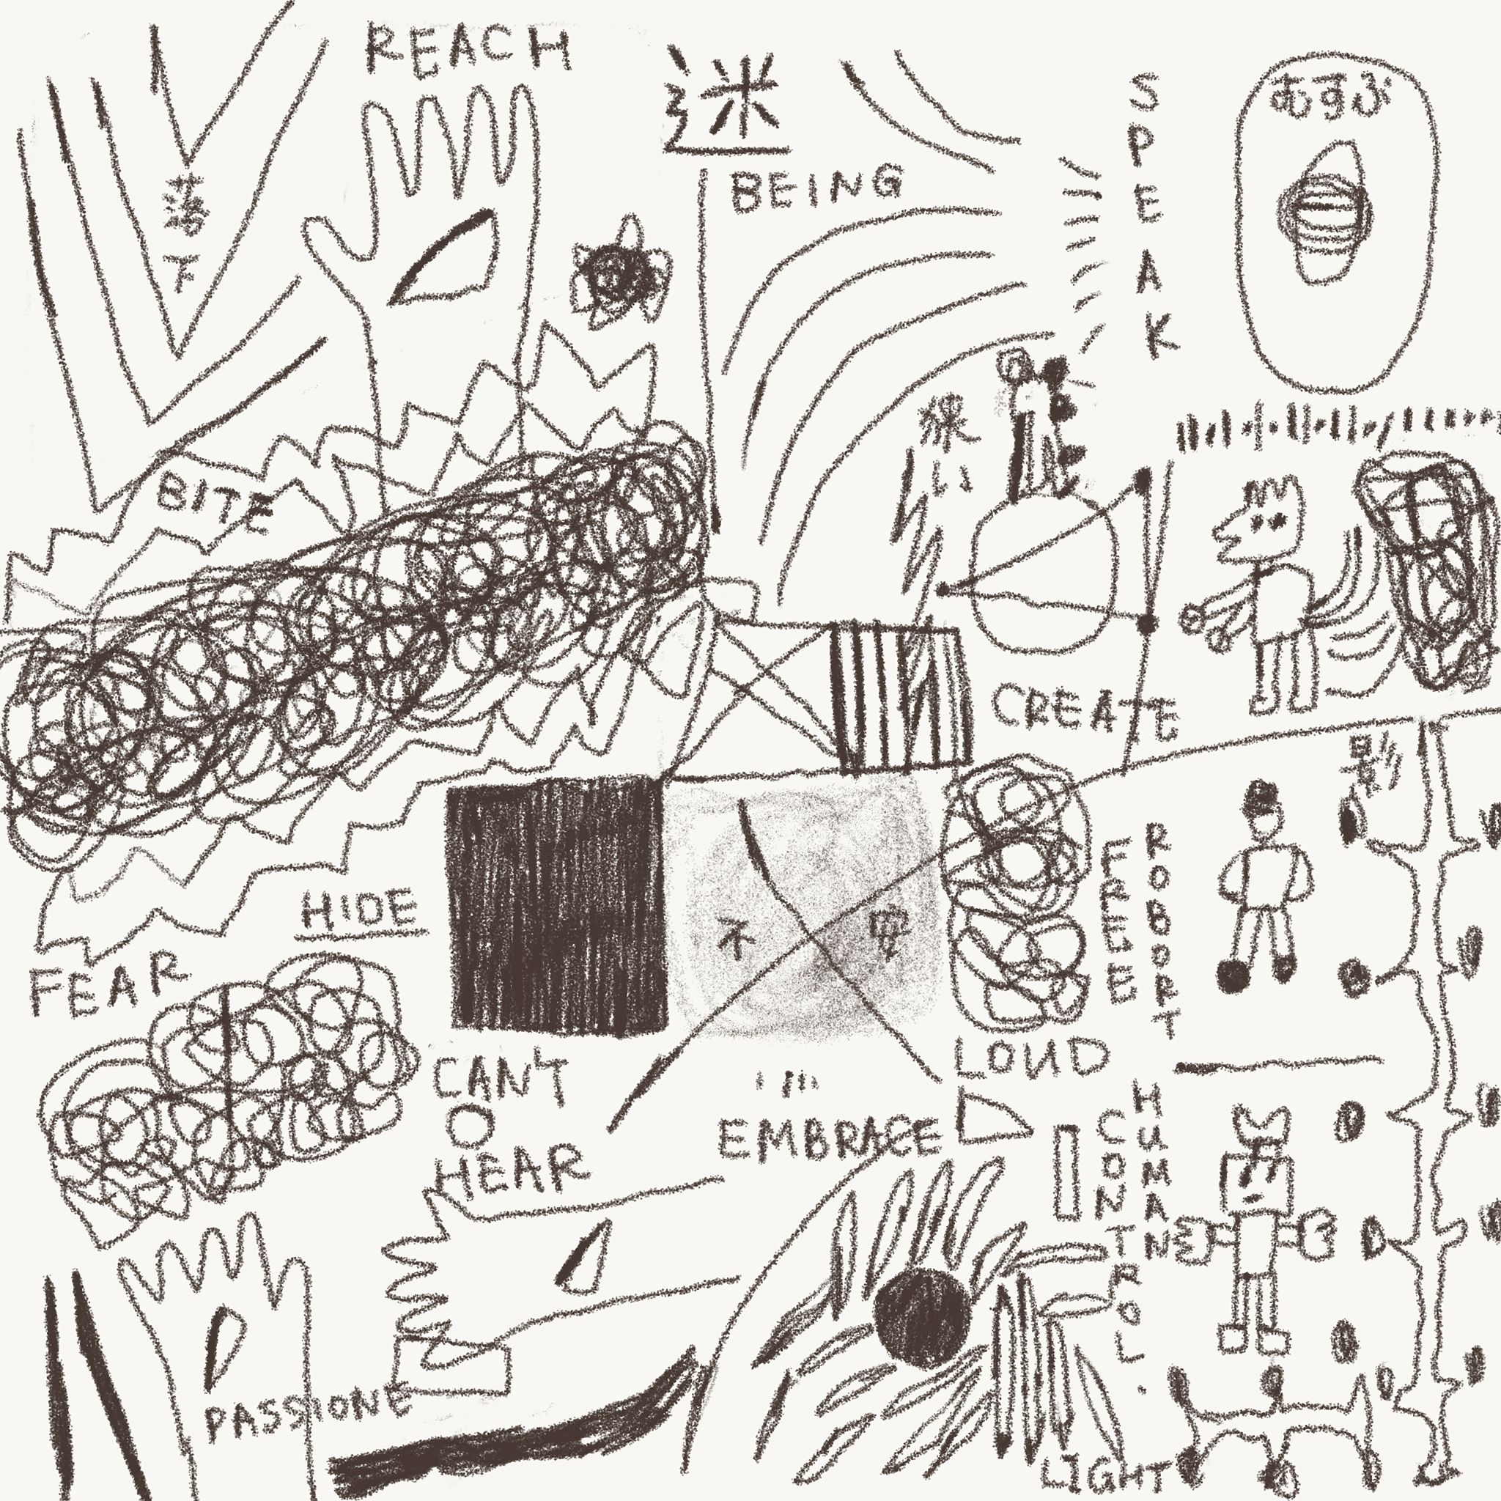

**Image Description:**The image is a chaotic, hand-drawn collage filled with words, sketches, and abstract forms. Scattered across the composition are phrases like "REACH," "BITE," "FEAR," "CREATE," "LOUD," and "HUMAN," alongside Chinese characters. It features drawings of hands, figures, and animals—including what appears to be a robot and a dog-like animal. Various patterns, lines, and scribbles enhance the expressive, frenetic energy of the drawing.

**Image Details:**  
Artist: Xin Chen  
Title: The State of Mind  
Date: 2024  
Descriptive tags: Illustration, Narrative, and Ambiguity

Instagram: @xinxinxin_chen ([click here to visit the artist’s Instagram](https://www.instagram.com/xinxinxin_chen))

**Question 1:** Why is the visual mark significant to you?

**Answer to Question 1:** The visual mark is significant to me because it captures who I am. It embodies the journey of my mind while drawing or making, reflecting my thoughts, emotions, and instincts. Each mark reveals what attracts me, what lingers in my memory, and what remains within me. It is both an imprint of my present state and a trace of my ongoing

artistic exploration.

**Question 2:** What is the role of written language in your work?

**Answer to Question 2:** To me, written language functions similarly to visual elements, shaping the composition and experience of my work. However, it also serves as a guide, leading viewers in a specific direction—whether precise, or deliberately ambiguous. Text adds another layer of meaning, inviting interpretation while maintaining a balance between clarity and mystery.

**Question 3:** How do childhood memories of play inform your practice?

**Answer to Question 3:** Childhood memories of exploring landscapes evoke a sense of freedom and discovery. I played among forms and colours without questioning their meaning, finding joy in the simplicity yet richness of the experience. This instinctive engagement with space and visuals deeply influences my practice, as I seek to recreate that sense of wonder, spontaneity, and unexpected encounter in my work.

[End of No Jobs in the Arts Issue 7]

**NO JOBS IN THE ARTS CIC, Milestone Studios, Unit 3, Rock Mill Lane, New Mills, High Peak, Derbyshire, England, SK22 3BN.** NO JOBS IN THE ARTS CIC is a not-for-profit, community interest company, registered in England and Wales, with the company number 14220745. Incorporated on 7 July 2022.

Email: nojobsinthearts@hotmail.com

Website: www.nojobsinthearts.co.uk

Instagram: @nojobsinthearts